**International Day of People with Disability**

**Game On – All Abilities Wheelchair Basketball**

**Social Story**



A social story is a document that uses storytelling techniques to explain new experiences and environments to people who are autistic or who have sensory sensitivities. Anyone who experiences anxiety, or is nervous when attending a place or event for the first time, may benefit from access to a social story.

This social story is for young people attending the wheelchair basketball activity at the Billy Dower Youth Centre on 30 November 2022. The activity will be held during the After School Drop-In session from 3pm to 6pm. This is a free event and no bookings are required.

Young people between the ages of 11 and 17 years can attend After School Drop-In sessions. You are welcome to attend with your support worker.

This document contains information about coming to the event at the Billy Dower Youth Centre, including images and information about the venue and the event.

**The Venue**

The activity/event will be at the Billy Dower Youth Centre. The address of the Centre is 41 Dower Street, Mandurah.

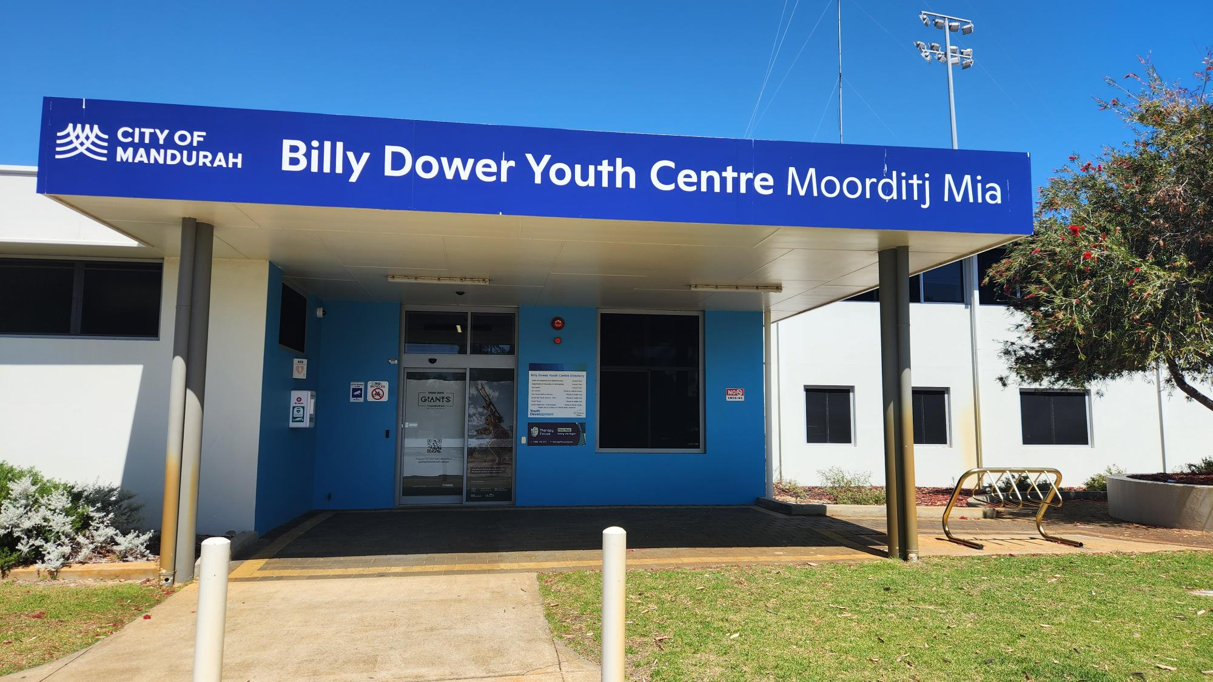

This is a photo of the Billy Dower Youth Centre.

There are parking options available out the front of the Centre including an ACROD parking bay. There is also a bus stop close by.

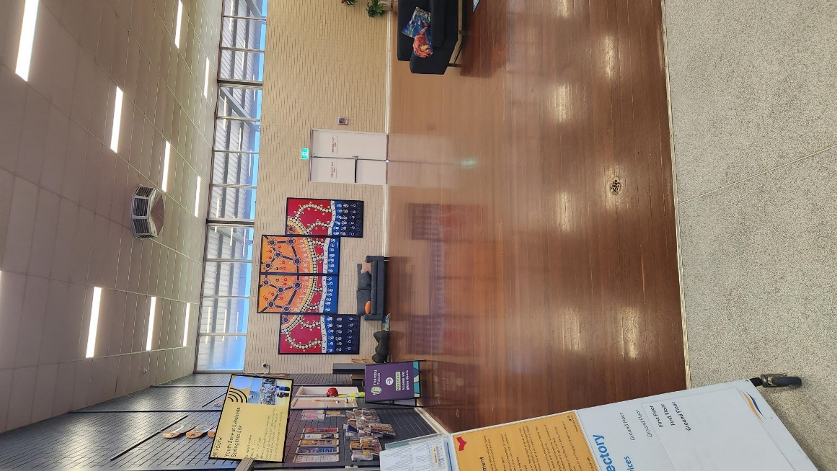

This is a photo of what the Centre looks like when you enter the front door. There is a large open space and there are couches in this area. You may go to this area to take a break from the wheelchair basketball activity.

There will be people working at the Youth Centre and there will be other young people attending the Drop-In session. You can ask a staff member a question and/or let them know that you are attending the wheelchair basketball session. Staff will be wearing black shirts with yellow trim and ‘Mandurah Youth’ written on the back in white.

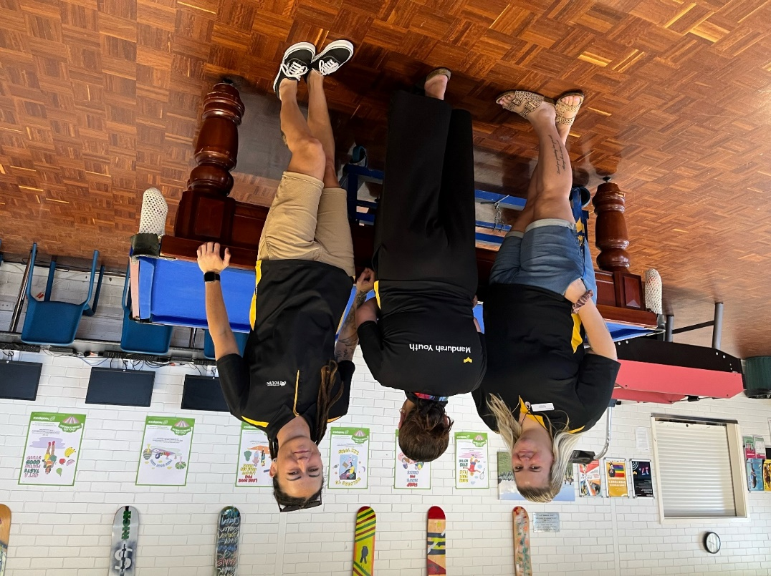

This is a photo of some of the team who work at the Youth Centre.

At After School Drop-In you can use the pool tables, do some art activities, use the computers, gaming consoles, air hockey, use the free WiFi and enjoy some snacks.

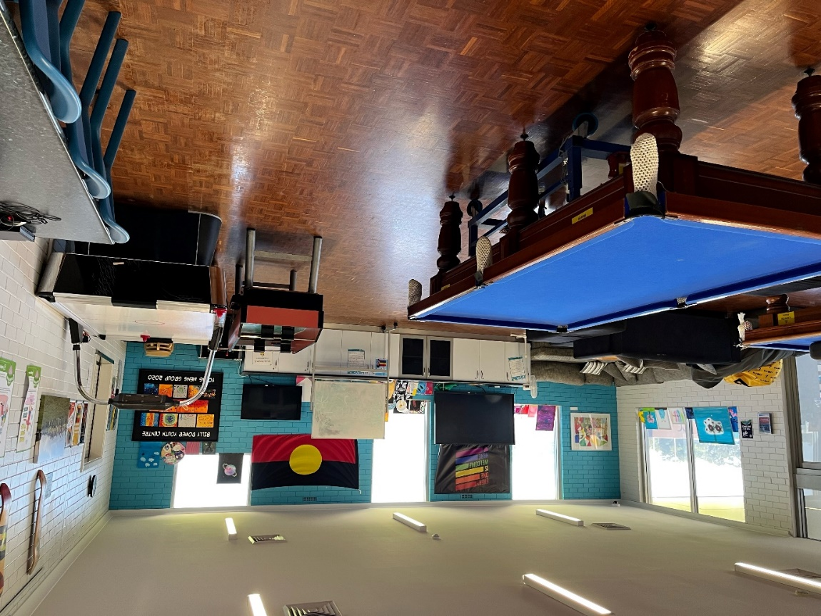

This is a photo of the games room at the Youth Centre.

There are toilet facilities at the Youth Centre including a wheelchair accessible toilet.

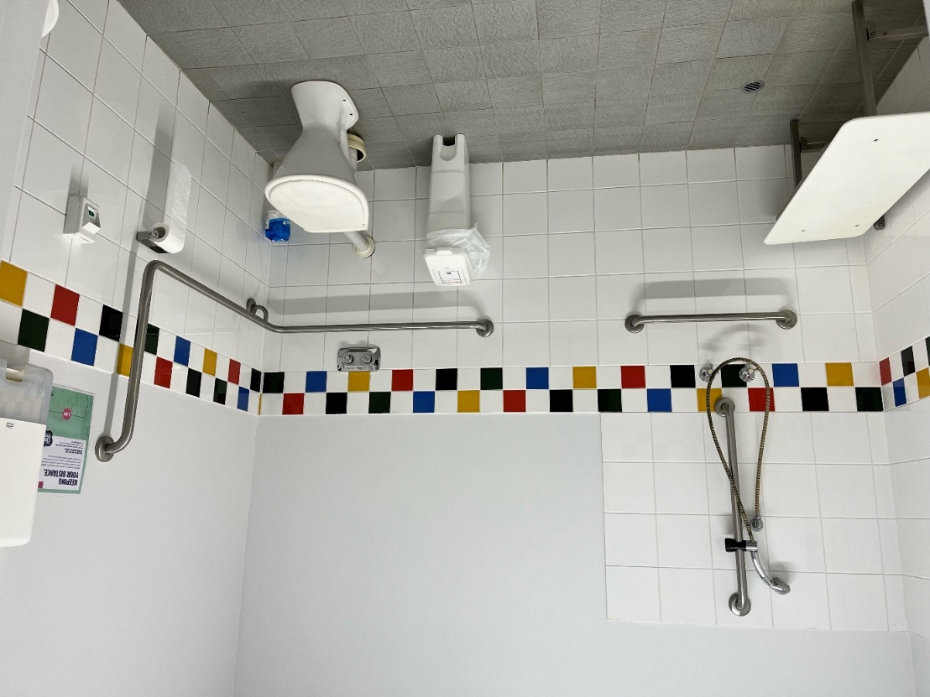

This is a photo of the wheelchair accessible bathroom at the Youth Centre.

The wheelchair basketball activity will take place in the outdoor area at the Centre.

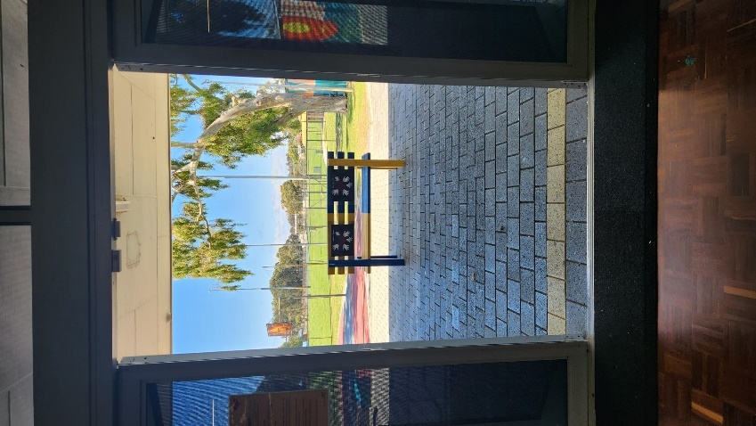

This is a photo of the doorway leading to the outside area where the wheelchair basketball activity will take place.

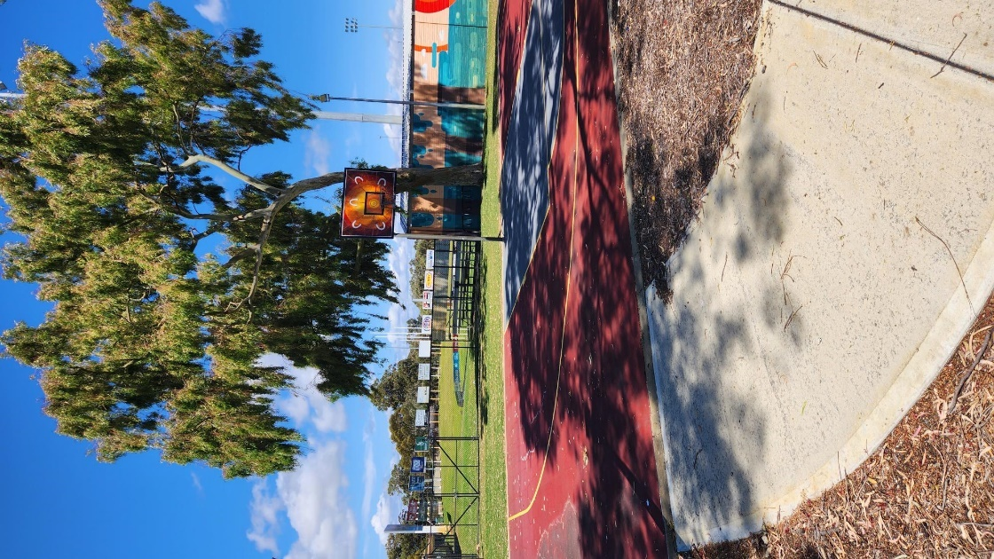

This is a photo of the outdoor area where the wheelchair basketball activity will take place.

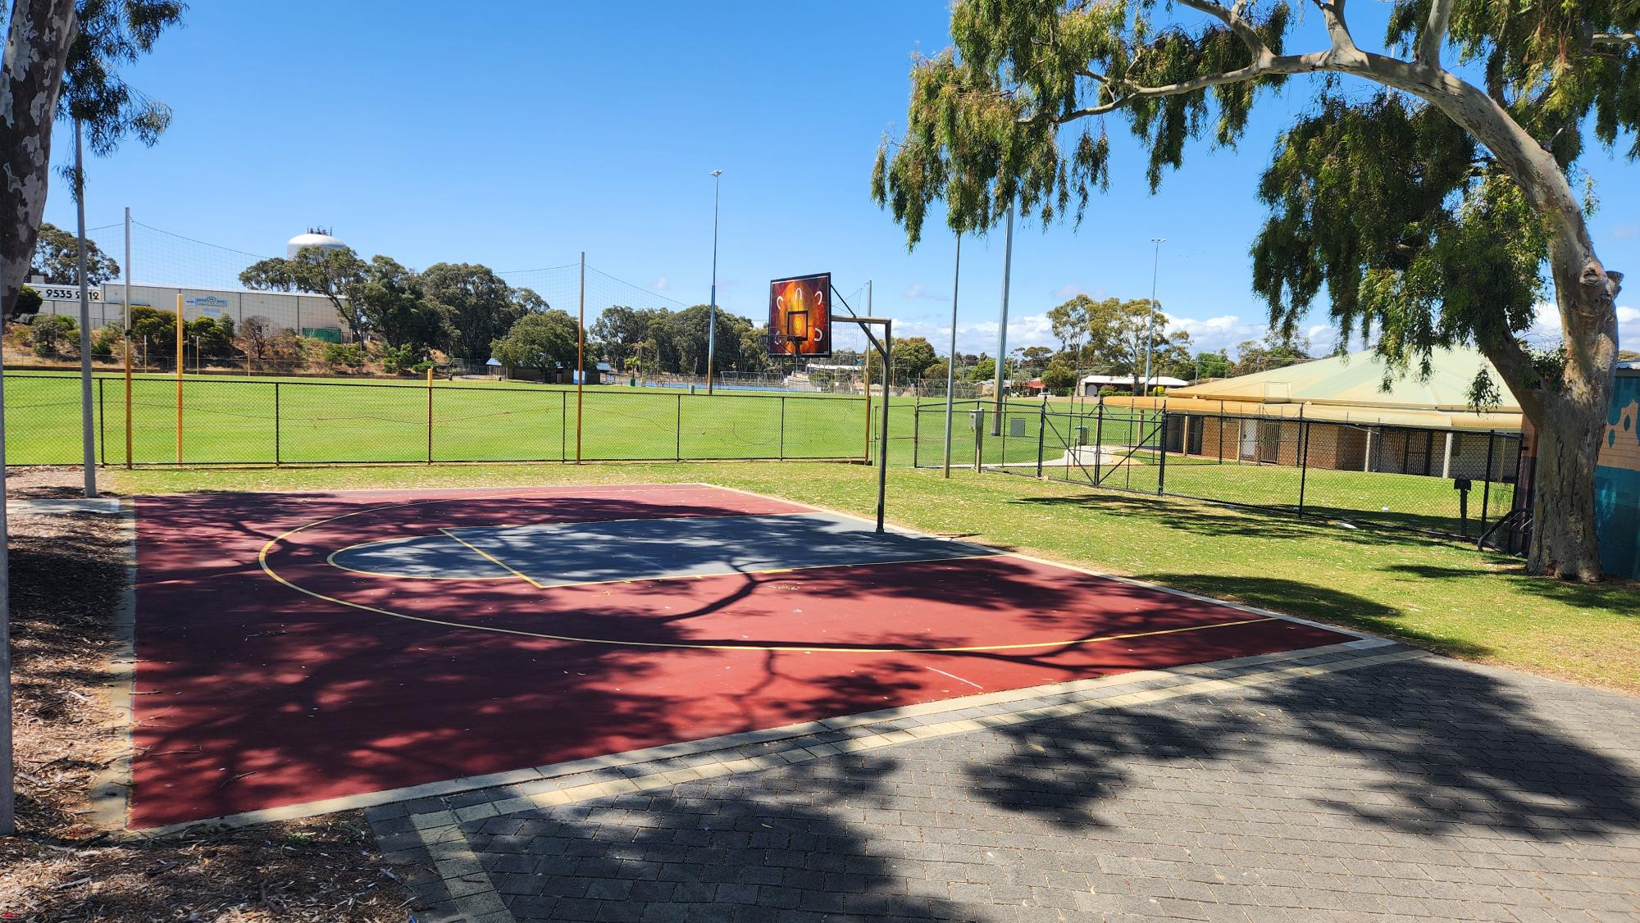

This is another photo of the court where the wheelchair basketball activity will take place.

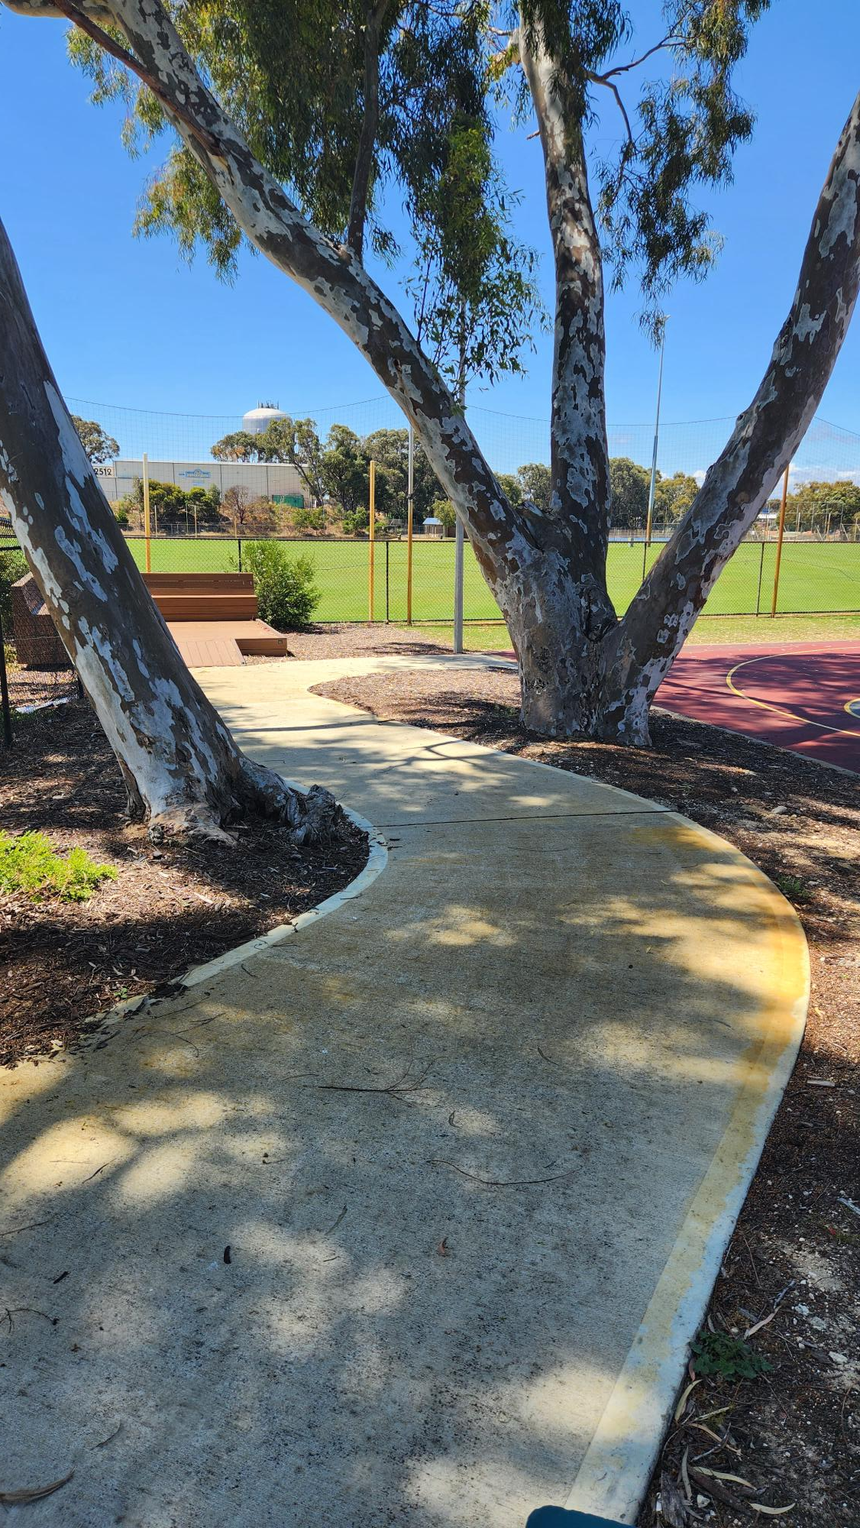

This is a photo of the footpath leading to the court. The court can be accessed by a wheelchair from the Youth Centre.

There will be an adult from an organisation (workplace) called Rebound WA who will talk to you about how to use a wheelchair including how to move around when in it. The adult will also talk a little bit about what it is like to have a disability and to use a wheelchair as part of everyday life.

You will be able to have a go of sitting in a wheelchair, but you don’t have to if you don’t want to. You can also change your mind and have a go a little later when you feel more comfortable.

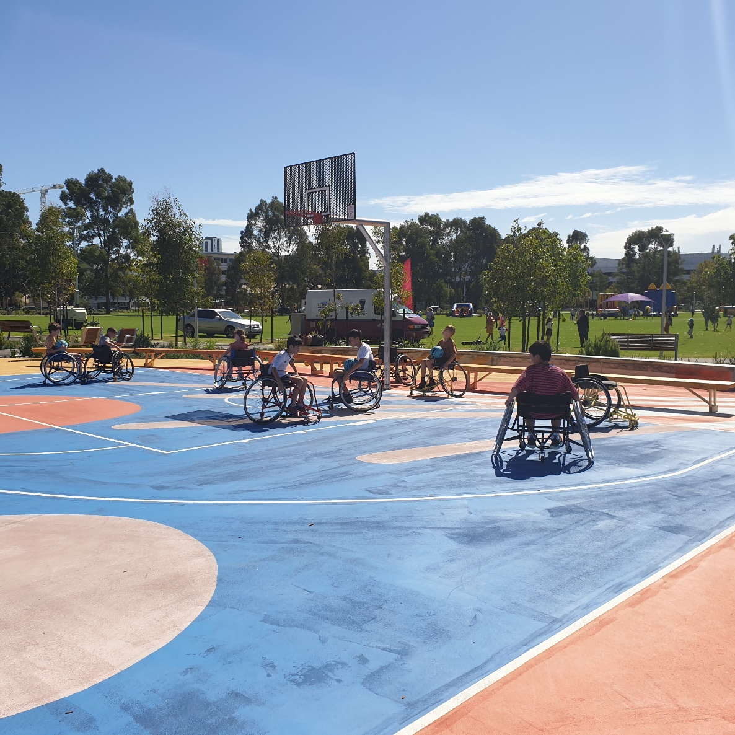

This is a photo of some young people participating in the wheelchair basketball activity at a different location. The young people in this photo are learning how to use the wheelchairs.

After the adult has shown people how to use the wheelchairs they will show people how to handle a basketball from the wheelchair and later everyone will get to play some games in the wheelchairs.

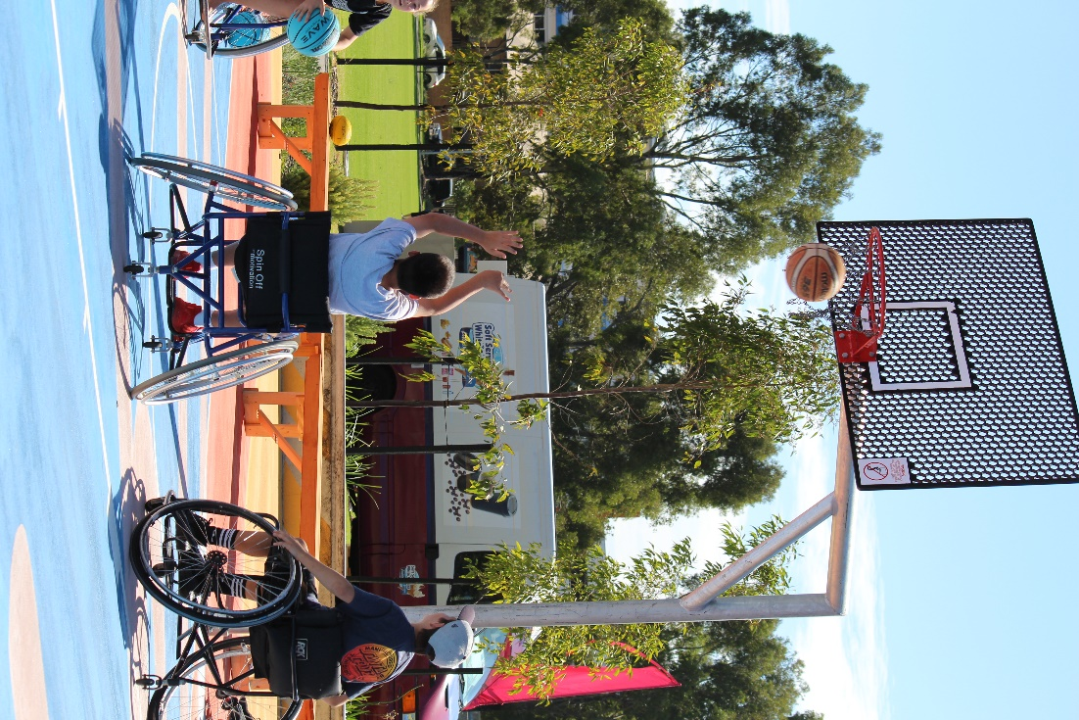

This is a photo of young people playing a game of wheelchair basketball.

For more information about the activity being delivered by Rebound WA, please click on the following website link <https://reboundwa.com/wp-content/uploads/2018/01/Wheel-Life-Information-Web.pdf>.

For more information about activities delivered by the City of Mandurah Youth team <https://www.mandurah.wa.gov.au/community/programs-and-activities/youth>.

For more information about this event please phone 9550 3670 or email [youth@mandurah.wa.gov.au](mailto:youth@mandurah.wa.gov.au). 

